YEAR 1 CLASS REQUIREMENTS – 2025

|  |  |
| --- | --- |
| ***These items will be stored and shared among the class throughout the year (no names required as all items will be shared)***   * 8 black whiteboard markers (Artline or Staedtler brand) * 8 glue sticks (UHU or Bostik brand recommended) * 12 lead pencils HB (thick triangular grip/Officeworks supplies these) * 2 large tissue boxes * 3 large packet of baby wipes | ***For your Individual child***  ***Please ensure all items are clearly labelled with your name***   * Twistable crayons (Crayola) * Textas (Faber Castell set of 10-12 no Sharpies) * 1 packet of coloured highlighters (set of 4) * 1 pair scissors * Small Pencil Case to fit crayons, textas, highlighters, scissors: no pencil tins or equipment for their desk. * 1 x Plastic document wallets * 1 library bag * Headphones with microphone (photo below) * 1 A3 Display book [J.Burrows A3 20 Pocket Display Book Black | Officeworks](https://www.officeworks.com.au/shop/officeworks/p/j-burrows-a3-20-pocket-display-book-black-ac2008802) (Only purchase if not purchased in 2024, otherwise please send in your child’s display book from 2024)      * 1 student diary ***(see picture below-no larger than A5)*** * Paint Shirt   ***Please purchase enough clear contact to cover 6 books that will be sent home in 2024.*** |

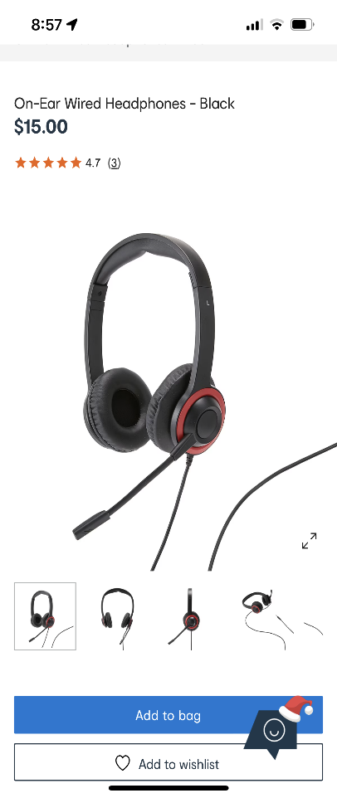 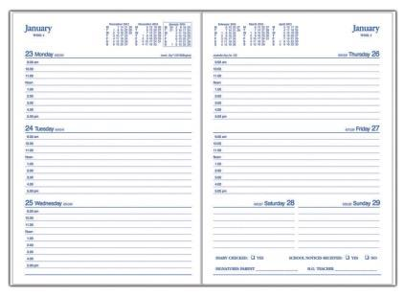

***The year 1 teachers look forward to seeing you in 2025.***