KINDERGARTEN CLASS REQUIREMENTS – 2025

|  |  |
| --- | --- |
| ***These items will be stored and shared among the class throughout the year***  ***(no names required )***  - 2 x 10 pack of black whiteboard markers ($5 per pack from Kmart)  - 8 x glue sticks (UHU or Bostik brand recommended)  - 2 x tissue boxes  - 2 x large packets of wet wipes  - 2 x 12 packs of Twistable crayons (Crayola)  - 1 x 20 pack of Textas (Faber Castell) | ***For your individual child***  ***Please ensure all items are clearly labelled with your child’s name***   * 2 A4 plastic document wallets (diary to be kept * Inside the wallet) * 1 library bag * [On-Ear Wired Headphones - Black - Kmart](https://www.kmart.com.au/product/on-ear-wired-headphones-black-43155545/) * 1 A3 Display book [J.Burrows A3 20 Pocket Display Book Black | Officeworks](https://www.officeworks.com.au/shop/officeworks/p/j-burrows-a3-20-pocket-display-book-black-ac2008802) * 1 student diary   ***(see picture below-no larger than A5)***   * Paint Shirt * Spare underwear and socks (to be kept in bag) * Lunch box and water bottle (easily opened by your child and labelled) |

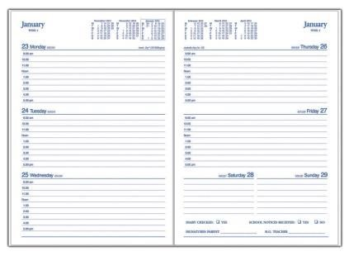

***The kindergarten teachers look forward to welcoming you to our St Cecilia’s community in 2025.***